**Design Pattern**

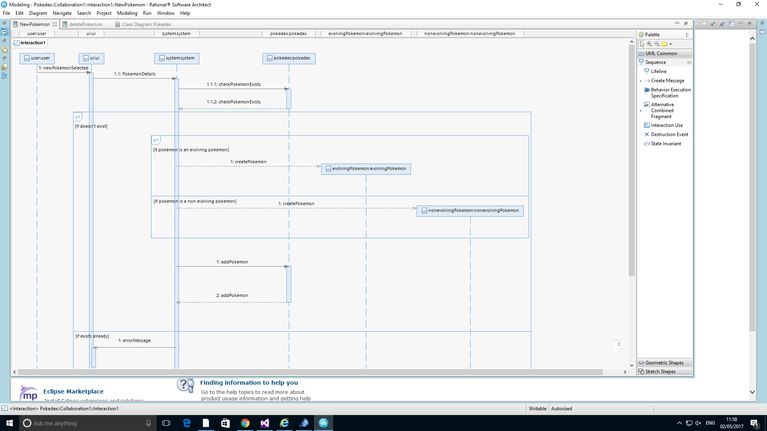

View

Control

Model

For the Pokedex system the design pattern that will be used is the Model View Controller, where the User Interface class is the view, system class is the control and Pokedex is the model. The user selects new Pokémon to be inserted and the UI sends the details to the system and the system then checks the if the Pokémon exists. If the Pokémon exists the error is sent to the user from the system to the UI otherwise the Pokémon is added to the Pokedex. Using the Model View Controller makes the design more flexible and extensible and it will make it easier when Pokedex is developed further in the future.